# **Defining Mentorship in a Research Setting**

# Part 1: An Overview of Mentorship

At its core, the scientific enterprise is hallmarked by the propagation of knowledge from skilled scientist to research apprentice. Currently, and for most of modern scientific history, the value and success of this knowledge propagation is measured almost exclusively on the specific outcomes of scientific discovery -- i.e. elucidation of mechanism, publications, funding, or other project-focused themes. Despite being embedded in a system completely dependent on people training other people, there has been little focus on how we can most effectively build and nurture the human relationships required to conduct science.

As our communities work toward creating a more inclusive scientific enterprise, we must do more to emphasize the sheer fact that science is a human endeavor. Through this set of materials, we hope to open up important discussions around mentorship among members of our scientific community. While there is no one best way to be an effective mentor, there are certain core expectations that can promote excellence in mentoring. By incorporating reflective mentoring practices into the academic framework, we can elevate the notion that science is indeed for everyone.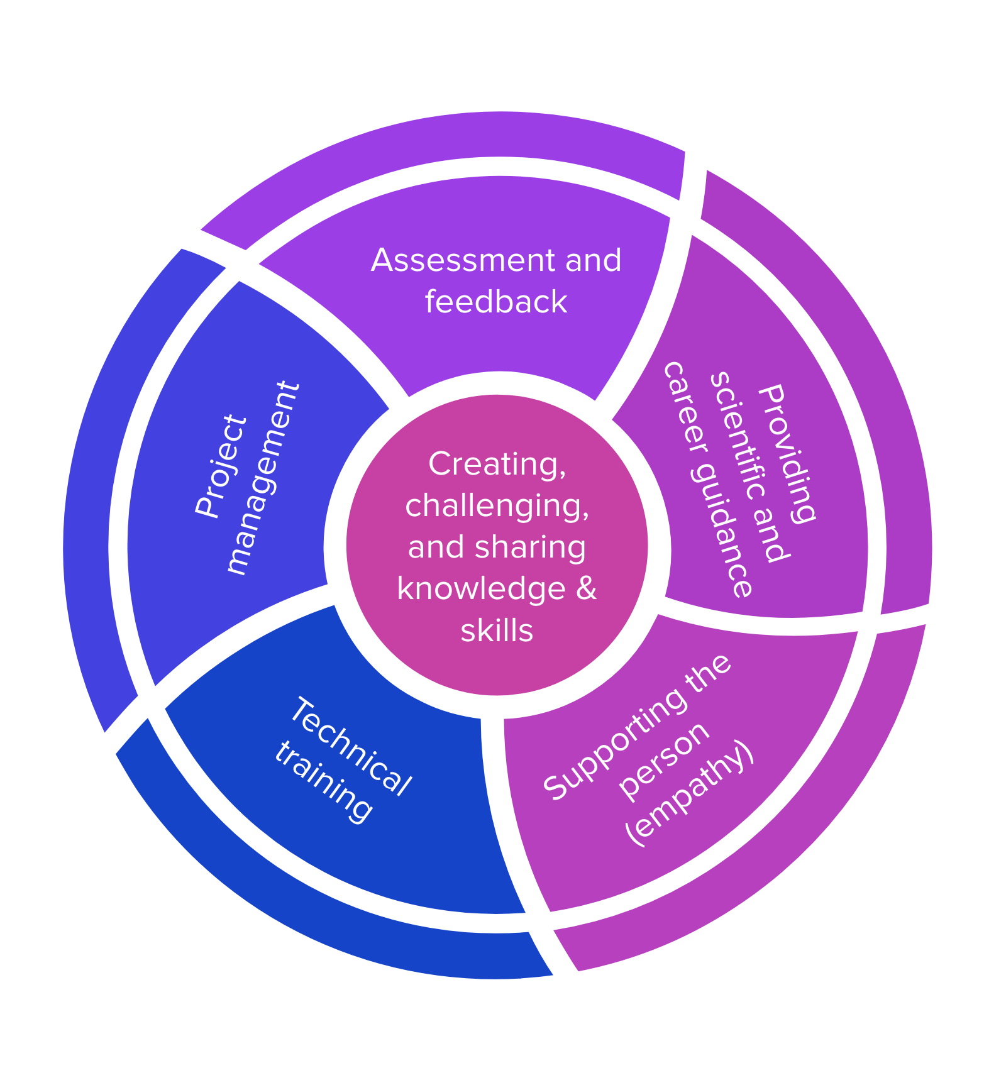

## Establishing the Meaning of Mentorship

At its baseline, mentorship is a partnership between someone who is experienced in a given area, and someone who wishes to gain experience in said area. When we engage in mentorship, we are promoting the transfer of knowledge between individuals, and within organizations. The way in which we approach mentorship as a community sets the tone for institutional culture, and paves the way for sustaining and scaling the scientific enterprise. In deconstructing what it means to be an effective mentor, we can consider five essential elements, described below.

**Assessment and Feedback**

How do you know if you are doing a good job as a mentor? This is often the million dollar question as context, personalities, goals, and general capacity will dictate your mentorship strategy. However, learning how to assess your effectiveness as a mentor is key. Essential to this process is the ability to honestly reflect on how it is going, and make any necessary adjustments to help streamline your approach. But it isn’t just about assessing how you are doing -- as a mentor, you will also have to give feedback to your mentee so they, too, can reflect and iterate as needed.

**Providing Scientific and Career Guidance**

Becoming a member of the scientific community is more than just learning how to pipette. There is often a complicated roadmap for learning how to navigate the general operational functions of any given laboratory or equivalent scientific setting, as well as how one might be able to leverage a scientific experience for career marketability. As a mentor, you are charged with helping your mentee understand these aspects of the scientific landscape to the best of your ability. If you are not equipped to provide this level of guidance, this is ok, but it is important that you identify a person or group who might be able to fill this role so that your mentee can maximize their learning experience (and perhaps you will learn something new, too).

**Supporting the Whole Person**

It is always important to recognize that science is done by people, and there are all sorts of contexts that have a direct influence on who we are, how we think, and how we work. When signing on to become a mentor, it is important to approach your mentee through an empathetic lens. By allowing yourself to think more fully about where your mentee might be coming from, you open up the channels for more efficient and effective communication, while also supporting mentee learning.

**Technical Training**

Conducting science requires a skillset that is not easily acquired from a textbook -- you learn by doing (and failing). As a mentor, one of your roles will be to teach your mentee the technical aspects of conducting science. This will look very different from lab to lab, bench to bench, or even project to project. Don’t forget to budget enough time for technical skills acquisition. For example, it might take your mentee 4x longer to set up an experiment that you can typically fly through.

**Project Management**

How do you achieve scientific goals with your mentee in the time you have together? This is where project management comes into play. Before starting any project, it is important to map out what you want to achieve, the steps you will take to get there, and consistent check-ins to assess how things are going. Our 2-4-6 Adaptive Action plan is a good way to think about project management in the context of your mentoring partnership.

# **Building Your Mentorship Strategy**

# Part 2: Finding a Mentoring Style that Represents the Culture You Want to See in Science

For nearly all of modern scientific history, the people conducting science did not necessarily represent the diversity of people and cultures that we all hope science will serve. As we work to bring more diverse people and perspectives into the scientific enterprise, we must also create an inclusive and supportive environment. By broadening our approach to consider not just the outputs of science, but who is driving scientific achievement, we can build in more inclusive practices. This refocusing exercise places mentoring at the forefront of our changing (for the better) scientific landscape.

We do not need to reinvent the wheel, however, as strategies to promote effective mentorship already exist. By learning how other professionals outside of science approach management and leadership, we can build on established best practices to find a tailored yet flexible mentoring style that takes into consideration diverse personalities, research goals, laboratory context, etc. Let’s stop building projects and labs, and let’s instead instill in people the capacity to effectively build projects and labs.

## 

## Drawing from Human Centered Design Theory

The essence of human centered design is iterative prototyping in a “people first” context as a means to creatively solve problems and drive innovation. But it isn’t just about identifying a problem -- it’s more about identifying the right problem, how this problem genuinely impacts people, and how to find effective and relevant solutions through empathetic reflection and iteration. To apply this philosophy to mentorship, it requires us to put people first, research second. This may seem difficult given traditionally held views within academic science research, especially in our high stakes environment. But, truly, the more you can invest in a person, the greater the potential return on your investment.

Human centered design dictates that the core of effective mentorship requires building a rapport with our mentees. It is not always clear how best to do this, but it is important to be authentic. Upon the start of your mentoring partnership, tell your story around what inspires you, how you come up with ideas (experimental and otherwise), and how you work to implement your ideas into practice. This “Inspiration → Ideation → Implementation” framework is a good way to build an important foundation with your mentee, allowing them a glimpse into how you view the world. Additionally, by sharing your work in a way that relates back to being human, you increase the chances of finding common ground. This, in turn, allows for more opportunities to check assumptions, while giving a sense of how to shape communication streams, and increasing overall efficiency in your work.

Applying Elements of Leadership to Mentoring

Becoming a mentor can be an effective way to build leadership skills, so why not approach mentoring with a leadership mindset? There is an enormous body of literature describing a variety of leadership theories, no reinvention of the wheel required. While this is by no means an extensive review of this literature, there is an emerging pattern around four key elements: self-awareness, communication, influence, and learning agility.

**Self-Awareness**

How well can you reflect on your situation? Can you identify when you should change course? How you should change course? Are you honest about your strengths and your weaknesses (and recognizing that knowing your weaknesses is actually a strength)? Knowing how and why you think the way you think, or react the way you react in specific situations can help you become more empathetic with your mentee. In developing awareness of self, you can reduce bias, and keep focused on the work.

**Communication**

Knowing how to effectively convey your thoughts and instructions, as well as being able to actively listen to your team members, is perhaps the most essential component of good leadership. It’s not always easy to assess your own clarity and effectiveness, so be to incorporate regular opportunities to both clarify your instruction, and learn from your mentee if they get it.

**Influence**

There is a distinction between managing activities and managing outcomes. Often, focusing on the latter is more conducive to getting people to follow your direction. Show that you can trust, and you will receive trust in return. Through your mentee’s eyes, it is likely that your scientific experience sets you apart from them -- they might be a little intimidated. Think about how you can include them in some decision-making. By allowing your mentee to feel respect, trust, and ownership of their project, you can get them to work hard for you!

**Learning Agility**

A central tenet of science is the ability to consider alternative interpretations in the face of new evidence. Do you embody this critical characteristic in your mentorship? Culturally sensitive practices tells us that people interpret information through the lens of their context, and sometimes we also make mistakes. Learning from these experiences helps to keep the mind open, maximizing innovation while minimizing bias. Failure and iteration are central to the scientific method. By demonstrating learning agility to your mentee, you can instill the qualities of resilience and persistence. Additionally, by keeping an open mind, you might also encounter new ways to think about an old problem!

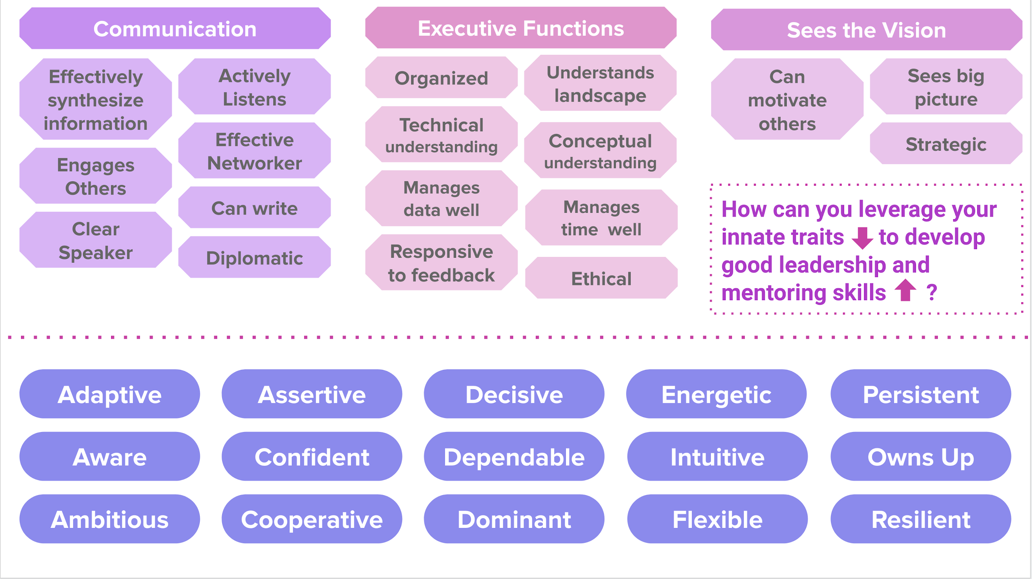

**Figuring Out How This All Applies to You**

How you determine your best mentoring strategy boils down to your natural modus operandi, but where do you start? One exercise to help with this process is doing an inventory on your traits, the innate qualities that pertain to your general nature (ie are you outgoing or introverted?). Assessing who you are -- and perhaps more importantly, who you aren’t -- can lead you toward building a mentorship skill set that works for you. It is worth noting that a mentoring skill set takes time to develop. Skills are best acquired and honed through experience -- no handbook can ever replace what you learn from doing. Whether it is your first time mentoring, or taking students is old hat, there is always room to grow.

Have a look at some example traits, and how they might apply to a set of skills that are relevant to mentoring.

# **Building a Suitable Project**

# Part 3: The Adaptive Action Plan

As a science research mentor, your first task is often to come up with a reasonable project for your mentee. There are many things you may want to consider:

* Choosing an essential part of your project can add significance to the mentee’s contributions and can streamline the time that you invest in your mentee as it is clearly furthering your own research efforts
* Choosing an offshoot of your project can give the mentee more freedom to explore the topic based on their own interests or experience, and provides a lower-stakes environment for failure
* Choosing a project too far from your main work or expertise can be challenging—remember that mentoring does take a lot of time and investment, especially up front

Or from another angle:

* Providing an initial experiment to try with a “let’s see what happens and go from there” attitude can be exciting for you, but may be a bit aimless for the mentee
* Structuring a project can feel daunting as we often find that science throws us curveballs; however, much of this post will address this particular theme and encourage you to be structured (and also adaptive) in your project’s structure and can work for both essential and offshoot projects. This is the Adaptive Action Plan.

“Adaptive Action Planning” is a technique used in employee on-boarding, project management, and other processes, where work is divided into 1–2 week cycles of planning, action, and revision. For example, in onboarding, one form of structuring these cycles is the “30-60-90 Plan,” where goals are laid out for the new employee at the 30-day mark, the 60-day mark, and the 90-day mark, with a commitment from their manager to revisit the progress and adjust course as needed at each of these milestones.

## An Adaptive Action Plan for Mentored Research

## An action plan structured with iteration and revision can fit well with the plans often made for scientific experiments. We suggest using a rapid version of this for planning to mentor a summer student or other short-term mentee by *establishing milestones of success for every two weeks, with weekly meetings on progress* to give time for frequent feedback and revision toward the milestones and larger project goals (e.g. results for their poster, completion of a defined body of work to which they have some ownership, the potential for autonomy, etc.).

This type of explicit planning can substantially improve communication and expose differences in expectations between the mentor and mentee. If the mentee can see from the beginning where you hope that they will be at the end, they are better able to take responsibility, and build independence toward these goals. They may also be better able to ask for help since they will at least know what to ask about. It can also be a very helpful learning experience as a mentor to reflect at the end of the summer on what goals were reasonable to achieve in this timeframe — this can help with future project planning, grant writing, and mentorship as you continue in your scientific career!

For example, summer students’ final poster presentations provide a way to structure the components of their research into familiar parts of the research process. Not all students have *final* results for the poster and that is okay; however, the student’s work should fit into a story and not just be disconnected or repetitive tasks supporting your research agenda.

It is also helpful to think about the nature of the research project you would like to develop for your mentee. For example, will the project involve a set of linear steps where one leads into the other? Or will the project involve a set of steps that can be done in parallel, or overlap in some way? Or perhaps there is a little bit of both… Whatever the project format, incorporating time for mistakes/redos, assessment and feedback, as well as knowing approximately how much time should be invested at each step along the way, will keep things running smooth (well, at least as smooth as possible). 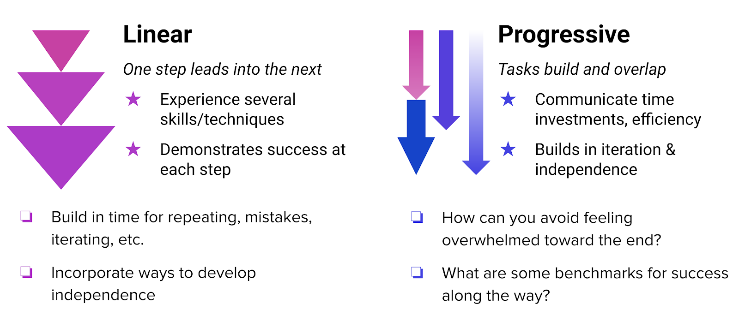

A Word on Goal Setting

When conducting scientific research, we often set out with an intended outcome in mind. Perhaps we hope to make suitable crystals for solving a protein structure, or we are hoping that our CRISPR’d animal model will replicate a particular aspect of a human disease. Whatever the case, it is common for us to set a research intention, and then work backwards to figure out the steps required to get there. The same strategy can be used for mentoring.

Using an Adaptive Action Plan can help articulate a set of goals for our mentoring partnership, including both scientific and professional. Once these goals are realized, we can work backwards to outline a set of actions that work toward meeting them. This process of working backwards from a stated goal is known as backwards design, and is a strategy developed to promote clear, effective planning with the end-goal in center focus. This may feel like a challenging exercise when there is a level of uncertainty inherent to any basic research mentoring situation. However, being clear and realistic about goal setting is a great first step in creating a successful mentoring partnership.

To help establish clear and realistic goals for you and your mentee, check whether they are **S-M-A-R-T**:

* **S**pecific (What will your mentee do? Define it clearly.)
* **M**easurable (How will they know when they’ve done it?)
* **A**ttainable (Is it possible in their context?)
* **R**elevant (Does it contribute toward the final poster/story?)
* **T**ime-Based (When should it be complete? How long will it take? Be specific.)

When building a set of SMART goals for your mentee, it is helpful to consider a few angles, as well as assess your mentee’s skills inventory. Using the backwards design approach, think about what you want done by the end of the mentoring partnership, and put this in context — what skills do you need to develop in your mentee to reach your preferred outcome? Is this skills acquisition realistic? What assets are you able to bring to this mentoring partnership? Can you articulate what success and failure might look like?

Adding onto the creation of SMART goals, we also must build in checkpoints to ensure trajectories are on target. Assessing project/mentee progress isn’t as simple as saying “I want my mentee to test the functionality of my engineered protein in cells.” How are you checking if the steps your mentee is taking make sense, and are paced appropriately? Here are some other aspects to consider when creating a set of SMART goals for your mentoring partnership:

**Establish a weekly meeting for reflection and suggestion**

Set a dedicated time each week for you and the student to reflect on the progress you’ve both made toward your mapped out milestones. These meetings should provide informational inputs so you can revise or sharpen your strategy, or even adjust what the milestones are (or both!). This exercise is central to reflection, iteration, and learning through the process of science. What works best? Determine the time and place, and no matter what, make it official and stick to it! Be sure to bring your Adaptive Action Plan, and make adjustments each week as necessary.

**Determine a set of realistic benchmarks that are tangible representations of the work you and your mentee are doing together**

You don’t have to include every detail in this plan, but rather focus on the threads where you expect the student to progress in output, autonomy, etc. through the course of your time together. One format for structuring this level of detail is in a table where you identify a few skills/processes/outputs and the expected milestones at regular intervals (see an example of this format below for our ~7-week summer program broken into 3 2-week segments).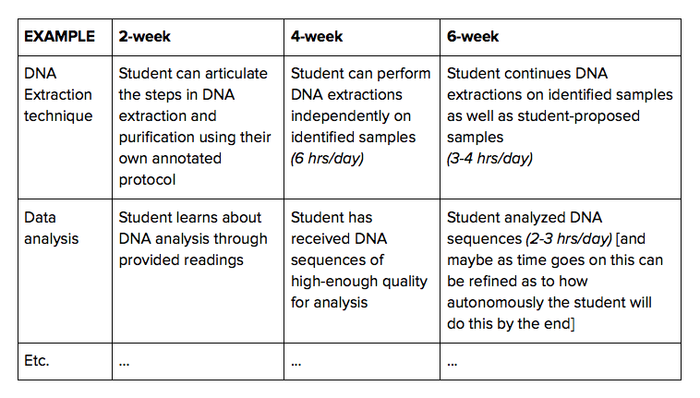

**Map out how much time you expect your mentee to spend on defined weekly tasks**

This could vary a lot by experiment or by week, but communicating this to your mentee is helpful for setting expectations and experimental goals. Building off of the example above, it might be helpful for your mentee to see that most of their time will be DNA extractions up to the 4-week cycle, but by the 6-week cycle they should be more efficient and able to do both their DNA extractions and analysis.

Considerations for Making a Plan that is Actually Adaptive

It is always helpful to think about which aspects of your mentees project are rigid, and where there is some flexibility. Categorizing your goals into “absolutely must happen,” “would be nice if this happens,” and “if there is extra time,” can help generate a manageable set of expectations. Keep in mind that what we plan and what actually happens can be different, so it is also helpful to have a backup plan, or at least consider what the project would like if you needed to slow down or speed up to accommodate the pace of your mentee. And, again, always, Always, ALWAYS build in time to collect and reflect on feedback.

Proposed Adaptive Action Plan Skeletons

For example, for the Rockefeller SSRP, mentors have 7-weeks with their mentees, so we propose breaking the time up into 2-week chunks (aka the 2-week, 4-week, and 6-week products) and a 7th wrap-up week to produce final output, wrap up loose ends, and clean up. *Informally, we call this the “2-4-6” plan*. Two different formats for outlining a project in this structure are featured below:

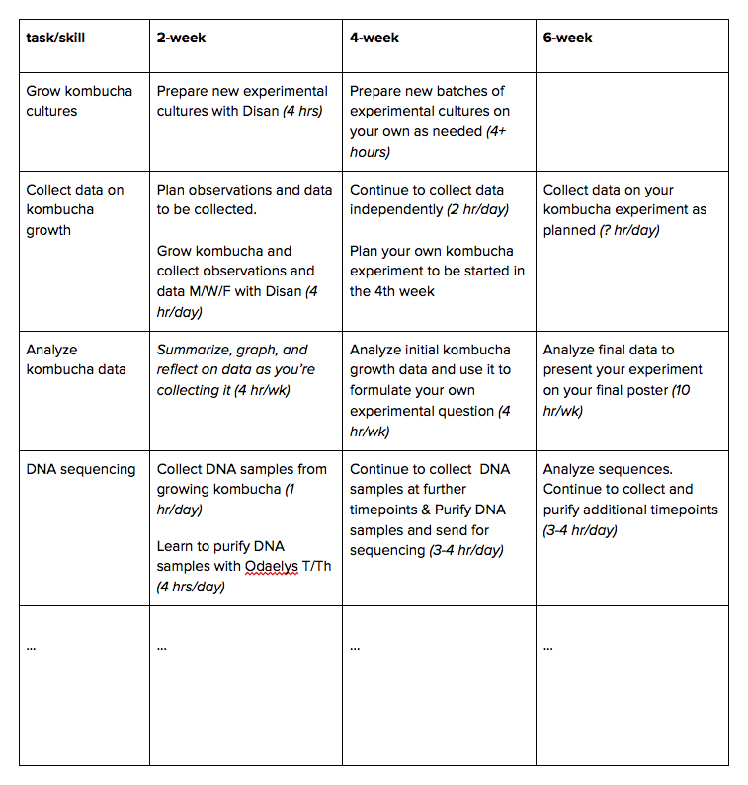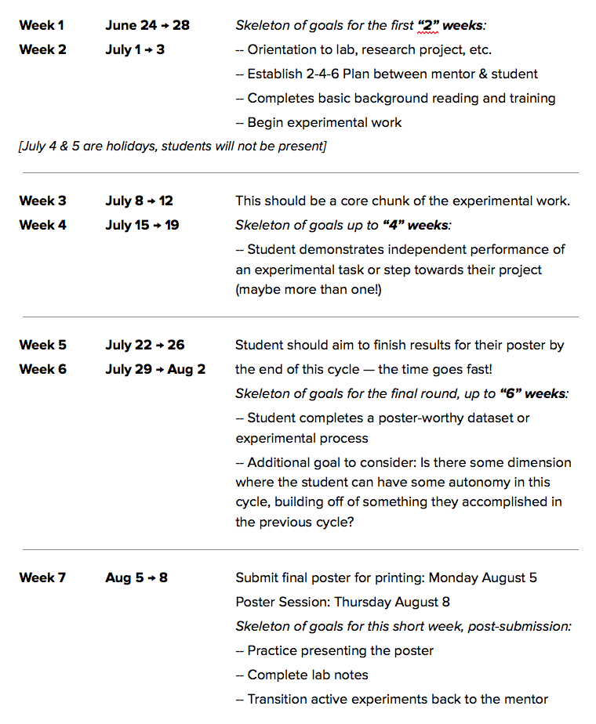

**Example of 7th week wrap-up notes:**

* Make sure DNA samples in the freezer are clearly labeled or thrown out.
* Clean up all kombucha jars from your experiments, leaving the mother culture to continue to grow.
* Photograph and then throw out all kombucha plates or other leftovers from experiments or data collected.
* Make sure any samples left in the lab for continued study are clearly documented in your lab notebook with future instructions.

Others helpful resources include:

[COMMUNICATING WITH YOUR MENTEE](https://phys.washington.edu/sites/phys/files/documents/grad/phd_mentorcommunicationcwd.pdf)

[Adaptive Action Guide](https://www.hsdinstitute.org/5.1.2.1-guide-adaptive-action-guide-2016.pdf)

You can find a blank template to create your own Adaptive Action Plan at the end of this Handbook.

# **Adapting Your Action Plan**

# Part 4: The Adaptive Action Plan, continued

So, now that you’ve created an Adaptive Action Plan, how do you make it really work? True to the name, you must build in time and strategies for checking in and adapting the plan to suit the progress being made.

## Regular Meetings

## Set a dedicated time each week for you and your mentee to reflect on the progress you’ve both made toward your mapped out milestones. These meetings should provide informational inputs so you can revise or sharpen your strategy, or even adjust what the milestones are (or both!). This exercise is central to reflection, iteration, and learning through the process of science. What works best? Determine the time and place, and no matter what, make it official and stick to it! Be sure to bring your Adaptive Action Plan, and make adjustments each week as necessary.

## Example: Maybe you can meet in the conference room for 20 minutes directly before or after your weekly lab meeting time? Or maybe you meet by your nearby coffee/tea spot first thing on Friday mornings?

## Practical Strategies for Assessing Progress with Your Mentee

## Your weekly meeting should not be the only time that you assess your mentee’s progress. There are some pedagogical tips and tools that provide an opportunity to elicit feedback from your mentee ongoing. Many of these are typical strategies borrowed from high school (and, in some cases, undergraduate) classrooms, and therefore, your students are likely to be used to this language and direction. Some of these communication and feedback strategies include:

## **Daily Digests or Do Nows:**

## Many students will be familiar with this structure for kicking off the beginning of a class at school. Essentially, you have prepared a prompt for your mentee to work on when they first arrive in the morning. It is not a “quiz” per say, but a way to help them focus on relevant material for the day, or even help them reflect on a skill or goal they are working towards. With a small amount of prep, this can help your mentee be productive when they first walk in the door without requiring you to drop what you’re doing to get them started.

## Example: Reviewing your notes from yesterday’s experiment, summarize the steps in DNA extraction and try to articulate any outstanding questions.

## **Exit Slips:**

## Many students will be familiar with this structure at the end of a class at school. It may consist of the same general questions every class, or different, more specific questions aligned with that day. Either way, the goal is to leave 10-15 minutes at the end of the day for student reflection. You may want to do these daily or just a few days a week, but they can be a great way to enhance communication and feedback in both directions, particularly if either of you is introverted or intimidated. You may consider asking both about content and about progress toward goals or benchmarks.

## Examples:

## What’s something you learned today?

## What’s something you’re confused about?

## One objective we spent time on today was ______. How would you rate your current level of mastery of this objective? What should you work on further? Explain.

## Did your group work well together? Y/N

## **Directly ask for feedback:**

## At your weekly meetings, or perhaps more often, ask for feedback from your mentee. This can include feedback on your Adaptive Action Plan, on your instruction, on the project you’ve laid out for them, etc. They may say nothing the first few times you ask and that’s okay, but it opens the door for more communication and demonstrates that feedback can go both ways. This hopefully can make it easier for you to offer feedback to them along the way, as it’s not just a top-down thing.

## The challenge is often accepting and reflecting on the feedback. If the student offers some feedback that surprises you, all you need to do in the moment is thank them for the feedback. Then, take a moment yourself to reflect on that feedback and decide how you’ll act on it. At that point, follow up with your mentee so they know you took their feedback seriously.

## **Listen Carefully:**

## What your mentee does (and does not) say can be a powerful set of information. Don’t fill in the blanks — ask questions and reflect back what you hear.

## Adjusting your Action Plan

## Work together with your mentee to rework your Action Plan and adjust your expectations. Have your mentee help estimate what things they will get more efficient at and what things they will continue to need more time on. More important than getting through a certain amount of stuff, your mentee can learn how to manage and reflect on their own productivity. This helps to build your mentee’s metacognition, a skill that is increasingly valued for its impact on life-long learning. Equally to learning opportunities, celebrate when something is accomplished in the expected amount of time!

## Together, you help your mentee to use the time that they have to make productive progress on their project. As the data come in, be sure to leave time for individual reflection by your mentee as well as reflection together—this can take a lot of time and is often initially overlooked! Finally, keep notes on this project so that you can reflect the next time you are designing a project for a mentee as well.

## **Others helpful resources include:**

## [COMMUNICATING WITH YOUR MENTEE](https://phys.washington.edu/sites/phys/files/documents/grad/phd_mentorcommunicationcwd.pdf)

# **Learning From Your Mentee**

# Part 5: Finding a Mentoring Style that Works for Your Mentee

As mentioned in previous sections, a baseline definition for mentorship is the creation of an educational partnership between someone who is experienced in a given area, and someone who wishes to gain experience in said area. When we engage in mentorship, we are promoting the transfer of knowledge between individuals, and within organizations. Being effective at mentorship involves honest self-assessment, implementation of leadership best practices, careful and thoughtful project planning, and operating with an empathetic mindset.

## Empathy

## It is this last point — empathy — that can be difficult to master, especially if you do not have a lot of mentoring experience. Human nature and behavior is incredibly complex, and is shaped by so many factors that are, in many ways, hard to define. The way we each interpret information can be markedly different from the person sitting next to us. As we work to be more culturally inclusive in science, we must be ready to work inside of a more flexible system.

## To be an empathetic mentor, you must work to hear and understand the feelings and perspectives of your mentee, and have the capacity to engage in helping behaviors that allow your mentee to effectively respond.

## Engulfed in empathetic mentoring is being able to control our own knee-jerk emotional responses, and work to always respond in a calm, clear way, keeping aware of your tone and body language. This is even more important when delivering negative feedback — you absolutely can express

## Photograph by Will Ragozzino

## disappointment or even discontent in a straightforward and calm fashion. Few people on this planet have perfected this skillset, but it is worth striving for. Being an empathetic mentor also involves understanding limitations — whether it is limitations of the experimental system, or of your mentees capacity, being flexible enough to switch gears to meet needs demonstrates an ideal mentorship quality. Even when you do less than your best, which happens, knowing how to reflect and adjust is a sign that you have the ability to iterate and improve.

## Context Matters

## There is no one “right” way to be a good mentor. But, good mentors are able to consider that any prospective mentee will likely come from a context that differs from theirs. It is not possible to fully understand the context of every mentee you come across, you can do your best to find common ground. It is also worth keeping in mind that the norms and expectations of the scientific community are likely to be markedly different from the cultural norms and expectations your mentee experiences in their home context, outside of science. Doing your best to see where a mentee might be coming from will help you to minimize biases, and identify ways to bridge gaps.

## Mentoring can involve students who are just entering the scientific enterprise. As such, we should keep in mind that we are working with younger populations (for example high school students for RockEDU’s SSRP, and undergraduates for Rockefeller’s SURF program). This may be their first professional experience, and they are most definitely still learning. It helps to remind ourselves how long it takes the prefrontal cortex — the region of our brain implicated in metacognition and decision making — to fully develop. This is all to say that our mentees are still working on developing how they process information, and might need assistance reaching the right conclusions.

## Related to their youthful inexperience, our mentees may have their own notions of what scientific research is about, and this can often fall into the “idealistic” category. When working with the SSRP classes through RockEDU-run courses and events, we work hard to temper these expectations so that the mentees can shift their focus toward the process of science, and making strong professional connections. Whether your mentee is in an official program, or is someone you decided to work with on your own, we recommend that you work to manage these expectations from the start. The Adaptive Action Plan is a way to help make explicit your goals, and regular check-ins can give you the opportunity to better understand the goals of your mentee.

## Lastly, mentees are coming in to learn, usually with a ton of excitement, and we should also keep in mind that they just don’t know what they don’t know. Through this mentorship opportunity, our students will be exposed to new techniques and concepts that will challenge them, sometimes in positive ways, and other times in ways that feel overwhelming (think about your own capacity for resilience to help engage our empathetic selves). You may have to find new, creative ways to get your mentee excited about something that feels challenging, or find strategies to help with motivation. Providing examples of what success looks like in your particular situation can definitely help put stuff into perspective.

## Photography by Scott Rudd Photography

## Immediately Establish Lab & Group Norms with your Mentee

## Help your mentee help themselves by setting expectations for how to work within the context of your lab and group culture. From the start of your mentorship partnership, be explicit about how things work in your context. Include information about the expected hours, the space(s) available to conduct their work, information about how and when you can be available to assist/provide feedback, and what the norms are for lab safety (attire, etc.). This could even include expectations for social gatherings — for example, does your lab eat lunch together every Friday? Are there any other social/fun traditions that can be extended to your mentee?

## 

## Remember that there are a lot of new things happening for your mentee. Be sure to give space for processing, and ensure that the pace of work matches the capacity of your mentee. It is ok to take some breaks! And if it doesn’t go as well as you had planned, there is always trying again.

# **Giving and Receiving Feedback**

# Part 6: Be a Kickass Mentor Without Losing Your Humanity

Giving and receiving feedback is a skill that can be challenging to develop. While there are a lot of models out there that specifically address feedback, at RockEDU we really like the [**Radical Candor**](https://www.radicalcandor.com/) approach. Based on Kim Scott’s book by the same name, this strategy emphasizes striking a balance between caring personally, and challenging directly. In using this strategy, you can avoid being overly empathetic (the “wet noodle” syndrome), or being aggressive and/or insincere. Below is a schematic from Kim Scott’s work summarizing the care-challenge spectrum.

## Radical Candor

## The formula for Radical Candor is simple: pay attention to your mentee’s work performance while also getting to know your mentee on a human level. Of course this is not to say that you need to be best friends with your mentee — but having some idea of their home life, hobbies, personal aspirations, or whatever it is that floats their boat can help you find effective ways to deliver feedback. This approach involves being critical of both wins and losses, while maintaining a connection to humanity. There is always room for improvement, and overall general success should not prevent us, as mentors, from pointing out how something can be iterated on to improve it. However, it is not just about delivering feedback. The Radical Candor model also involves opportunity for you to receive feedback, just as much as you give it. This gets back to the Adaptive Action plan model, which emphasizes regular check-ins for assessing progress, and responding accordingly.

## Image from https://www.radicalcandor.com

## The Radical Candor model also reminds me of how the most influential leaders can simultaneously exude strength (can challenge directly) and warmth (can care personally). There are several celebrities who fall into this category, and could serve as examples or even role models as you work to meet your full mentorship potential. For example, by watching how Michelle Obama or Jacinda Ardern operate in the public eye, we can pick up tips and strategies for presenting ourselves as mentors who can provide feedback in straightforward ways without sacrificing the warmth we have the capacity to emit.

## Maximizing Efforts for Giving and Receiving Feedback

## Giving and receiving feedback hits on nearly all aspects of leadership, and is an essential component for making progress in your mentorship — both as a professional, and in your science. To make this point, imagine a time in your scientific career where you did not get the feedback you wanted, and how this impacted the way in which you moved forward. Now imagine what might have happened if you had a mentor give you the feedback you needed to hear in order to get where you needed to be. Can you identify the disconnect?

## Generally speaking feedback should be given and received in a way that is timely, accurate, and actionable. This latter point is important because unless you can articulate a way to adjust, or help your mentee brainstorm a way to address a specific challenge, feedback is utterly useless. Here are a few other suggestions for giving/receiving feedback:

## **Yes, and…** Borrowed from the timeless improvisational comedy toolkit, incorporating “yes, and…” into your feedback repertoire will help your mentee feel heard, creating a more effective line of communication, and encouraging free sharing of ideas. This is in direct contrast to the “No, but…” line of feedback, which basically shuts everything down.

## **Avoid the Compliment Sandwich.** A compliment sandwich is a way of giving a critique flanked by two unrelated compliments. This method is not only ineffective, it also can leave your mentee feeling confused about what just happened, and how they should respond. No one wants to eat your compliment (aka “shit”) sandwich, so don’t serve it up.

## **Explore Challenges Together.** When a problem is nuanced or complicated in some way, our mentees may not have the experience or understanding to navigate toward a reasonable solution. By making the time to go through a challenge together, you can identify areas where you can be more explicit, while also providing the specific guidance required to overcome this bump in the road. This is an excellent way to both give and receive feedback.

## **Ensure the Process is Transparent.** Issues arise if there is any confusion about the details of the process. By articulating why a specific strategy should be taken to address a problem or answer a question, it provides a helpful context, and allows our mentee to more easily visualize (and work towards) the end goal.

## **Give Your Mentee Time to Process, Reflect, and Respond.** It can be really difficult to adequately respond in the moment. If you are giving feedback, either at the bench, or in your weekly check-in meetings, do not expect an immediate response. In fact, explicitly tell your mentee “why don’t you take some time to think about this, and get back to me with your ideas by [insert a specific time/date/location].” Make sure there is time for follow up!!

## **It is OK to Give Feedback in the Moment.** If you can clearly see that a mentee is approaching an experiment incorrectly, or is not interpreting information in the right way, it is helpful for you to point it out in the moment. But, as mentioned above, do not give feedback unless it is actionable. Make sure you are demonstrating what should be happening, and how to get there.

## **Summarize Back What You Heard Your Mentee Say.** An exercise that normalizes our communication streams with our mentee is to simply summarize what our mentees are telling us, and make sure we are on the same page. Miscommunications are often at the root of professional issues, so taking the time to ensure clarity is worth the investment.

# **Example Scenarios for Providing Feedback**

# Part 7: How would you respond?

Below are a set of scenarios to practice how you’d react, offer feedback, and make the most of these difficult situations. There is not one right answer—but, we hope our responses provide some ideas and helpful suggestions.

## A Needy Student Who’s Oblivious About Your Time and Availability

## **A scenario exploring time management, encouraging mentee independence, and setting boundaries**

## You really like Lewis. He is friendly and works hard. The problem is that Lewis is needy. It seems he is always dropping in your office to “talk things through,” or stopping you in the hallway to have you help him solve a problem. You feel that Lewis is bright enough and experienced enough to handle most of the problems he brings to you on his own. You are not sure if Lewis lacks confidence, or if he just wants someone to talk to. Lewis seeks you out so frequently that you have started to find ways to avoid him.

## *How can you help Lewis step up and start solving problems on his own, and come to you only when really necessary?*

## **RockEDU Potential Response:** Schedule a formal meeting to discuss the boundary issues with Lewis, being sure to give a snippet of what the meeting will entail. You could say:

## *Hi Lewis, I appreciate that you are putting a lot of effort into your work with me, and your willingness to talk through our protocols and related lab work. I think you’re ready to take on a bit more independence in finding a solution to some of the problems that arise. I’d like to see you try to solve more things on your own, as opposed to coming to me as soon as you encounter a challenge. How does that sound to you?*

## You might include some specific ways in which Lewis can try to work things out, such as where to find protocols, googling tips, or other questions.

## You can also tell Lewis that you are happy to take his questions, but since you also have to make progress on your projects, that it would be helpful if you could set a time for checking in, or maybe ask Lewis to write all q’s down on a post-it that you can review at the end of the day

## 

## 

## When Your Mentee Gives YOU Feedback

## **A scenario exploring feedback and reflection, communication, and relationship dynamics**

## Julie is a postdoc who is mentoring an eager high school student, Kate. Kate is new to research, but is willing to work hard to learn as much as possible. Julie believes in the idea of mentoring, and genuinely wants her students to succeed. While Kate is extremely open to correcting course, she isn’t finding Julie’s feedback helpful, and is confused on how to adjust so that she is meeting the research goals. Nervously, Kate sets up a meeting with Julie to talk about how she is feeling, and conveys that she is not connecting with how Julie is explaining the techniques.

## *You are Julie. How would you respond in this situation?*

## **RockEDU Potential Response:** Kate, thank you for sharing this with me. I see that you are nervous, but I want to tell you that this is a partnership. It is important that we are on the same page, so telling me is a good thing. As I think about how I can adjust how I am teaching you these skills, it would be helpful to know the ways in which you like to receive information. For example, do you like things written out? Do you prefer visuals? … OK, great. I will look into this, and hope that you can feel comfortable letting me know when things aren’t landing.

## 

## Addressing a Toxic Lab Environment

## **A scenario exploring power dynamics, communication, feedback and reflection, organization, and relationships**

## Samantha is Andrea’s summer mentee. Samantha has grown accustomed to weekly meetings with her mentor, and feels confident in her success and quality of work. Yet, she consistently sees tense exchanges between two labmates, and it is impacting the productivity of the lab. Seemingly “out of the blue,” the HOL approached Samantha while she was at her bench and asked her if she believed that the lab was well run. Samantha loves the work that she is doing, and worries about jeopardizing her professional relationships by giving critical feedback about the often tense environment, and out in the openness of the lab lab. She also wants to provide a thoughtful and insightful response, rather than just saying “yes” or “no.”

## *How would you advise Samantha to reply to this question?*

## **RockEDU Potential Response:** This is definitely a question that requires a bit of thought and diplomacy, and is probably a conversation for behind closed doors. As such, it might be helpful for you to suggest that you think you have useful feedback, but would like an opportunity to gather your thoughts. You can say “I really enjoy being here, and definitely want to think about this question so i can give you my best answer. Do you mind if we schedule a meeting for later so I can put my thoughts together so I can be most helpful?”

## Then you can take your time to craft an answer, thinking of ways to best describe the conflict and how it is impacting the lab. Language could be:

## *I feel that you are giving me incredible support, both as a person, and as a scientist. I appreciate the resources that you are providing, and your openness to helping me troubleshoot. However, sometimes I feel a little stifled by lab dynamics between X and Y, and I think there is a general consensus among others in the lab. [add 1 or 2 specific examples of what is happening, and their consequences] I think it would be really helpful if you could potentially address this, and in general, do more to help manage some of the interpersonal dynamics going on.*

## Giving Feedback in the Moment

## **A scenario exploring providing feedback in the moment and giving instructions at the bench**

## Kennedy is working at the bench setting up a restriction enzyme digest that hasn’t worked the 1st few times they’ve done it, even after going over the protocol several times with them. You decided to check in one day while they’re working on this experiment and realized that they’ve been pipetting 20 uL instead of 2 uL (and also using the incorrect pipettes). Kennedy has confidently expressed that they knew how to properly use the pipette, but now you realize they do not. As a mentor, you’re frustrated because it’s two weeks in and you see that they lack some of the fundamentals to perform the experiments correctly.

## *How can you provide feedback in the moment without expressing your anger and frustration?*

## 

## **RockEDU Potential Response:** (RockEDU offers classes the first week of SSRP for students that covers the fundamentals like pipetting, making solutions, operating lab equipment, etc)

## *Oh Kennedy, I think I know why the experiments have not been working. *Brings over a p20 and p200 pipette* It’s super easy to get confused with volumes and these pipettes, especially when we’re not paying close attention. I’ve also made this mistake before. *goes over the differences in both pipettes and the different volumes that we use them for* Even though it may seem like a silly mistake, it happens to the best of us. But if you are unsure about something feel free to ask again.”*

## A lot of times our apprehension can lead to weeks of failed experiments that could have been avoidable, it’s always better to be safe than sorry.

## Managing the Expectations of an Overachiever

## **A scenario exploring managing expectations, communication, and relationship dynamics**

## Claire is a high functioning high school student, and has taken every science class in her school with high proficiency. One of the units in her research class focused on CRISPR, and after learning that you will be her mentor, Claire gets in touch with an outline for a CRISPR project. She is very assertive with her request. Your work does not have a CRISPR component, yet you feel pressured by Claire’s assertiveness. You try to think of ways you can map out a project for Claire that involves CRISPR, but given your lack of experience with this technology you are feeling uneasy about incorporating it. You want to tell Claire that this isn’t feasible, but do not feel comfortable with confrontation.

## *How can you convey to Claire that you do not have the ability to include CRISPR in her summer project?*

## **RockEDU Potential Response:** (In general, high school students have had limited exposure to the disciplinary breadth of biomedical research, and don’t know what they don’t know. Sometimes when a student is drawn to science, they can latch onto an idea or concept that is introduced to them, and don’t get that, at their stage, experiencing the research process and cultivating a relationship with you — the writer of any potential letter of rec — is more valuable than conducting a specific research activity. Also, the techniques that you are including in her project are more appropriate for the SSRP timeframe, and represent fundamental principles that she might encounter in future lab experiences)

## *Claire, thanks so much for creating this fantastic research outline. I really appreciate that you have put thought into your work with me. The project I have outlined for you does would not involve CRISPR technology, but would give you a great window into [xyz]. However, we have a ton of seminars on campus where scientists talk about using CRISPR. Let’s be sure to attend those together, and talk about these talks afterwards, too.*

## 

## 

## 

## 